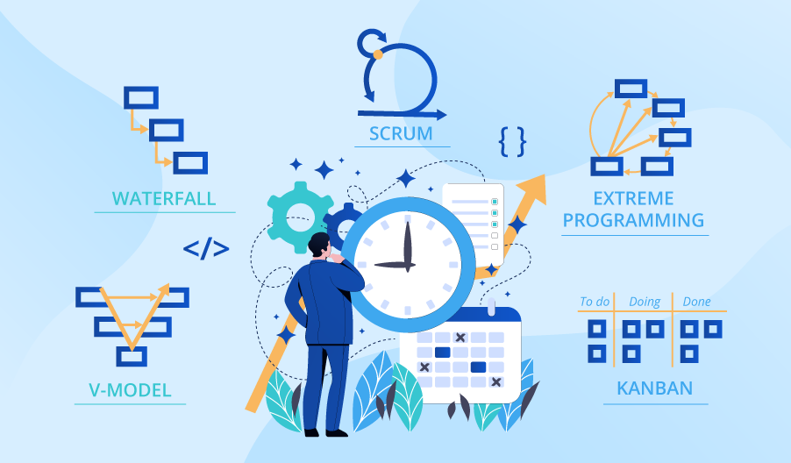

**SE423**

**Software Project Management**

**Assignment**

**Assignment 5.**

Answer the following questions:

1. Discuss the various factors that must be considered when deciding whether or not to implement a change in a software project.
2. Describe how advances in technology can impact software subsystems and lead to the need for change. Provide examples to illustrate your points.
3. As a software project manager in a company specializing in offshore oil software development, you have been tasked with analyzing the factors that affect system maintainability. Develop a plan for analyzing the maintenance process and establishing appropriate maintainability metrics for your company.
4. Identify and describe the three main types of software maintenance. Discuss why it can be challenging to distinguish between these types of maintenance in practice. Provide examples to illustrate your points.

Submit your answers to LMS as PDF file.